Ahnaf Muhammad Alfariza  
16/395991/PA/17332  
Machine Learning IUP

Iris Classification using Single Layer Perceptron

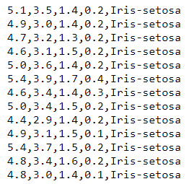 In this task, we are going to use iris dataset. It consists of three classes which are iris-setosa, iris-versicolor and iris-virginica. Each class has 50 data, and so all the dataset will have 150 data. The attributes are sepal length, sepal width, petal length and petal width.

. . .

the dataset

Then, we will classify this data by using single layer perceptron. Below is the architecture of the SLP

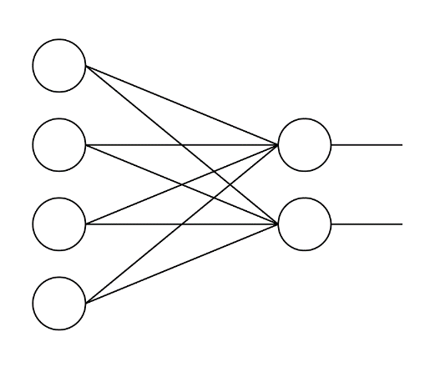

|  |  |  |
| --- | --- | --- |
| Iris-setosa | 0 | 0 |
| Iris-versicolor | 0 | 1 |
| Iris-virginica | 1 | 0 |

Implementation

For implementation, I use python programming language.